sameer makwana(09bce026)
7Ce-A
Data warehouse Management

Practical 8 : Apriori Algorithm

In data mining, association rule learning is a popular and well researched method for discovering interesting relations between variables in large databases

e.g., promotional pricing or product placements. In addition to the above example from market basket analysis association rules are employed today in many application areas including web usage mining, intrusion detection and bioinformatics.

Through this experiment we will explain frequent patterns and an efficient algorithm to discover them (Apriori) from large datasets. In data mining, Apriori is a classic algorithm for learning association rules

Problem Formulation:
- Set of items: I
- Set of transactions: D (t∈D⇒t⊆I )
- For an itemset X⊆I
- support(X) = number of transactions containing X/∣D∣
- Association rule: r=(X-Y = > Y), with Y ⊂ X ⊆ I
- Support(r) = Support(X)
- Confidence(r) = Support(X)/Support(X-Y) where X-Y is the set difference
- INPUT: (I, D, minsup, minconf) with 0 <= minsupport <= 1 and 0 <minconfidence<1
- OUTPUT: all rules r s.t. support(r) >= minsupport and confidence(r) >=minconfidence

arff file :

@RELATION apriori

@ATTRIBUTE I1 {1}
@ATTRIBUTE I2 {1}
@ATTRIBUTE I3 {1}
@ATTRIBUTE I4 {1}
@ATTRIBUTE I5 {1}

@DATA

1,1,?,?,1
?,1,?,1,?
?,1,1,?,?
1,1,?,1,?
1,?,1,?,?
?,1,1,?,?
1,?,1,?,?
1,1,1,?,1
1,1,1,?,?

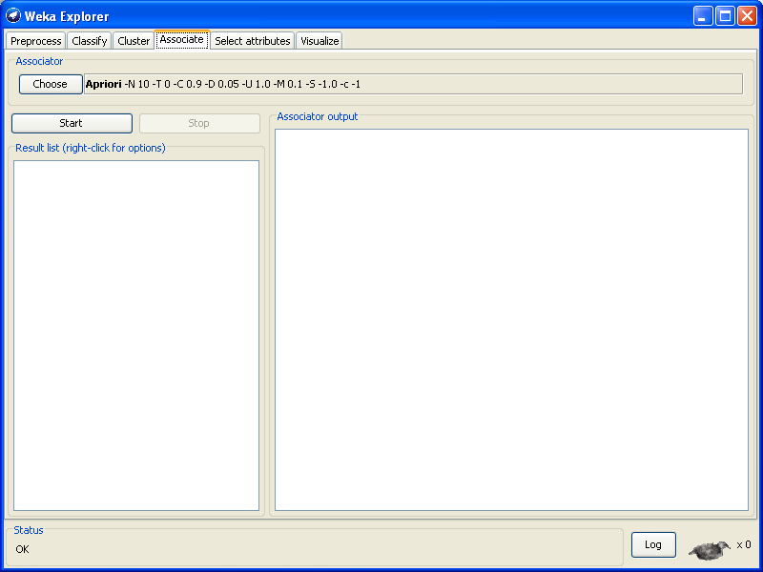

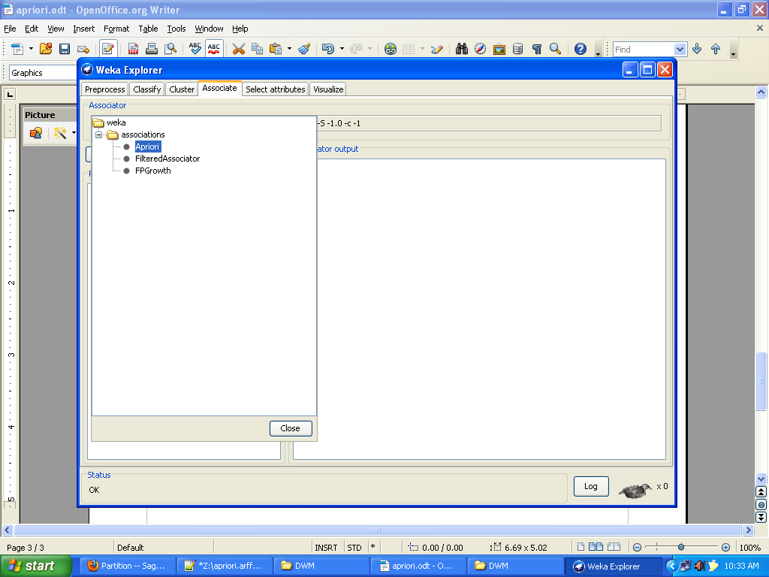

Output : ->

=== Run information ===

Scheme: weka.associations.Apriori -N 10 -T 0 -C 0.9 -D 0.05 -U 1.0 -M 0.1 -S -1.0 -c -1
Relation: apriori
Instances: 9
Attributes: 5
I1
I2
I3
I4
I5
=== Associator model (full training set) ===

Apriori
=======

Minimum support: 0.16 (1 instances)
Minimum metric <confidence>: 0.9
Number of cycles performed: 17

Generated sets of large itemsets:

Size of set of large itemsets L(1): 5

Size of set of large itemsets L(2): 8

Size of set of large itemsets L(3): 5

Size of set of large itemsets L(4): 1

Best rules found:

1. I5=1 2 ==> I1=1 2 <conf:(1)> lift:(1.5) lev:(0.07) [0] conv:(0.67)
2. I4=1 2 ==> I2=1 2 <conf:(1)> lift:(1.29) lev:(0.05) [0] conv:(0.44)
3. I5=1 2 ==> I2=1 2 <conf:(1)> lift:(1.29) lev:(0.05) [0] conv:(0.44)
4. I2=1 I5=1 2 ==> I1=1 2 <conf:(1)> lift:(1.5) lev:(0.07) [0] conv:(0.67)
5. I1=1 I5=1 2 ==> I2=1 2 <conf:(1)> lift:(1.29) lev:(0.05) [0] conv:(0.44)
6. I5=1 2 ==> I1=1 I2=1 2 <conf:(1)> lift:(2.25) lev:(0.12) [1] conv:(1.11)
7. I1=1 I4=1 1 ==> I2=1 1 <conf:(1)> lift:(1.29) lev:(0.02) [0] conv:(0.22)
8. I3=1 I5=1 1 ==> I1=1 1 <conf:(1)> lift:(1.5) lev:(0.04) [0] conv:(0.33)
9. I3=1 I5=1 1 ==> I2=1 1 <conf:(1)> lift:(1.29) lev:(0.02) [0] conv:(0.22)
10. I2=1 I3=1 I5=1 1 ==> I1=1 1 <conf:(1)> lift:(1.5) lev:(0.04) [0] conv:(0.33)

